Figure-1.1. Verilog Source code for 64-bit FullAdder
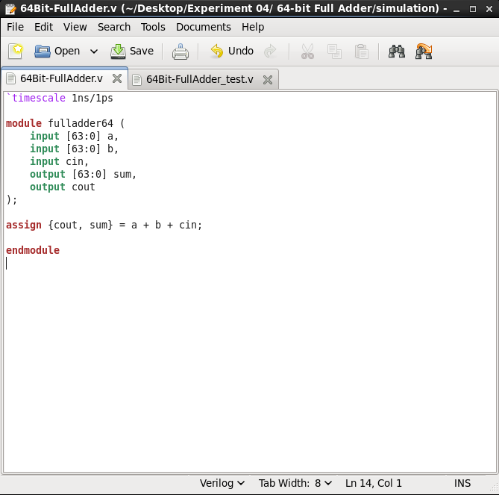

Figure-1.2. Verilog Source code for 64-bit FullAdder Test-bench
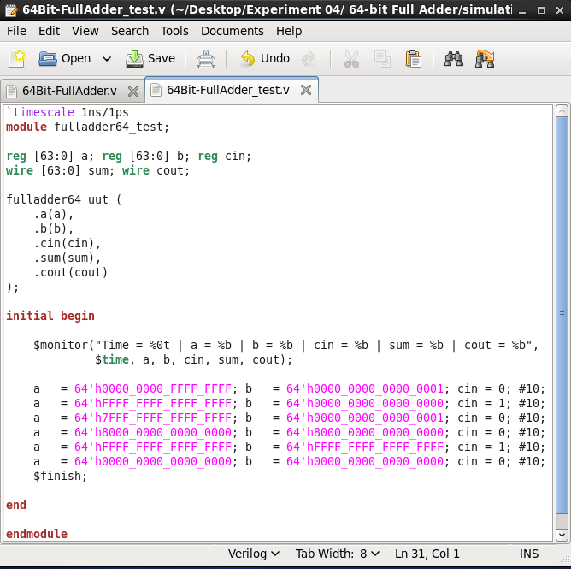

Figure-1.3. NCLaunch window of 64-bit FullAdder showing successful compilation (no errors in the Command Entry Window)
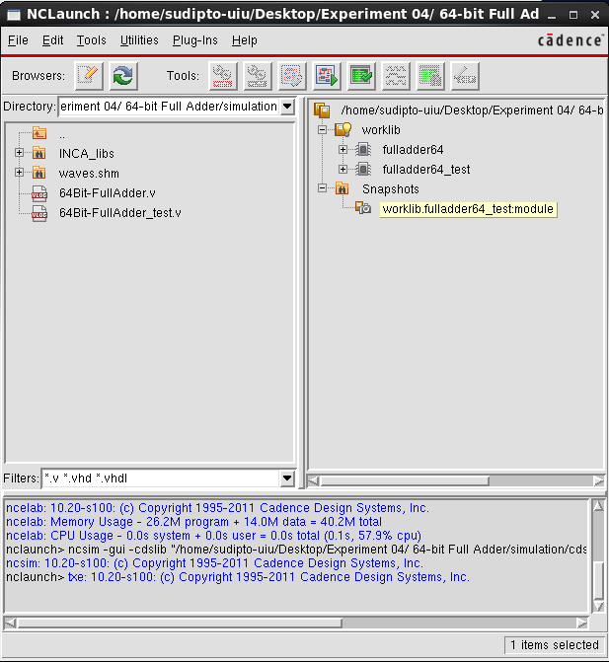

Figure-1.4. SimVision window for 64-bit FullAdder Test-bench, showing the inputs, selector lines, and output
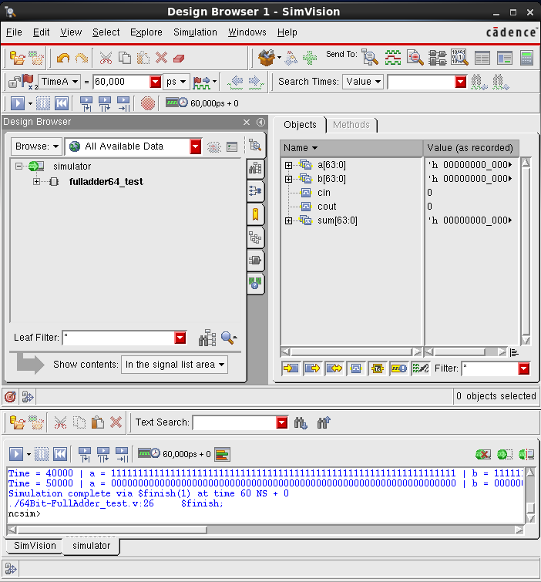

Figure-1.5.1. SimVision Output Waveform for 64-bit FullAdder Test-bench, showing the all inputs, selector lines, and output
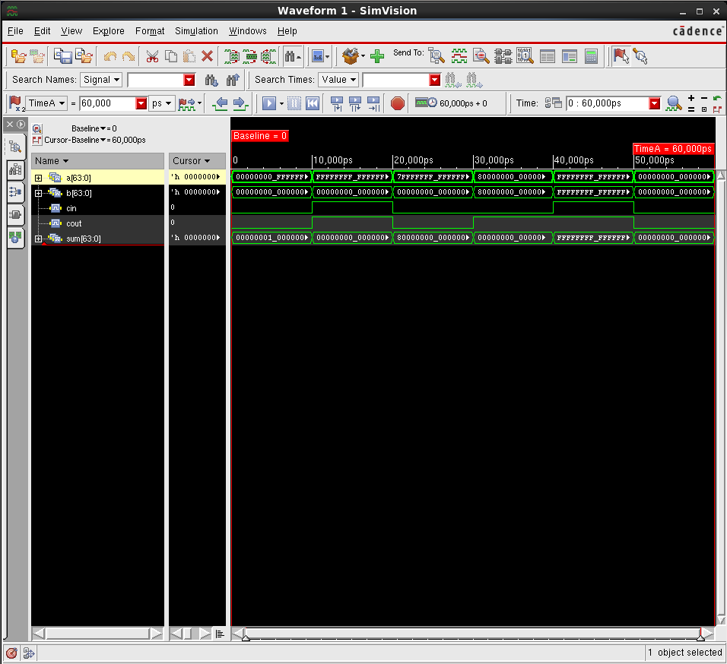

Figure-1.5.2.1. SimVision Output Waveform for 64-bit FullAdder Test-bench, showing the input(A63-34), selector lines, and output
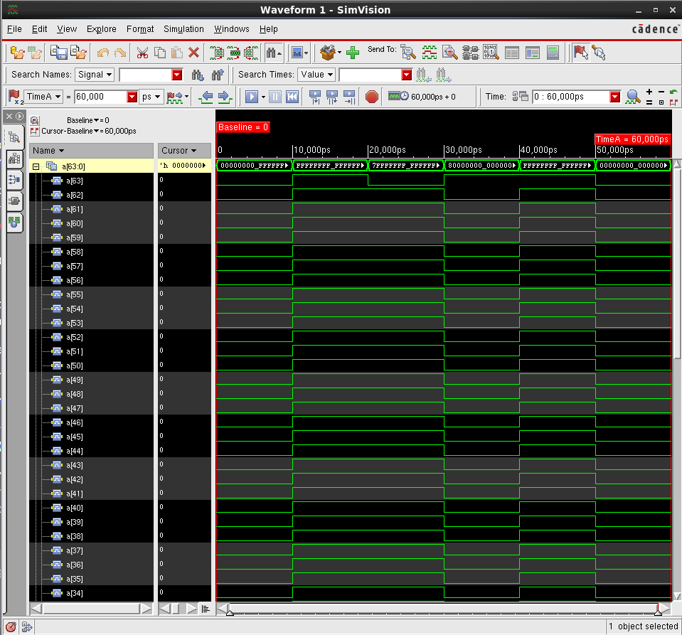

Figure-1.5.2.2. SimVision Output Waveform for 64-bit FullAdder Test-bench, showing the input(A33-0), selector lines, and output
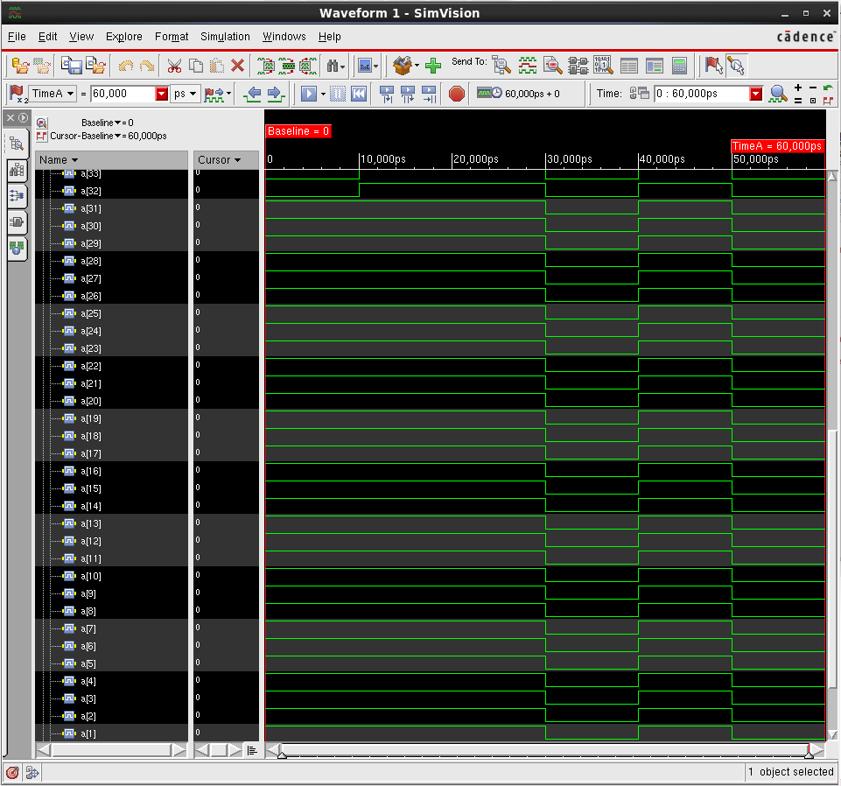

Figure-1.5.2. SimVision Output Waveform for 64-bit FullAdder Test-bench, showing the input(B63-32), selector lines, and output
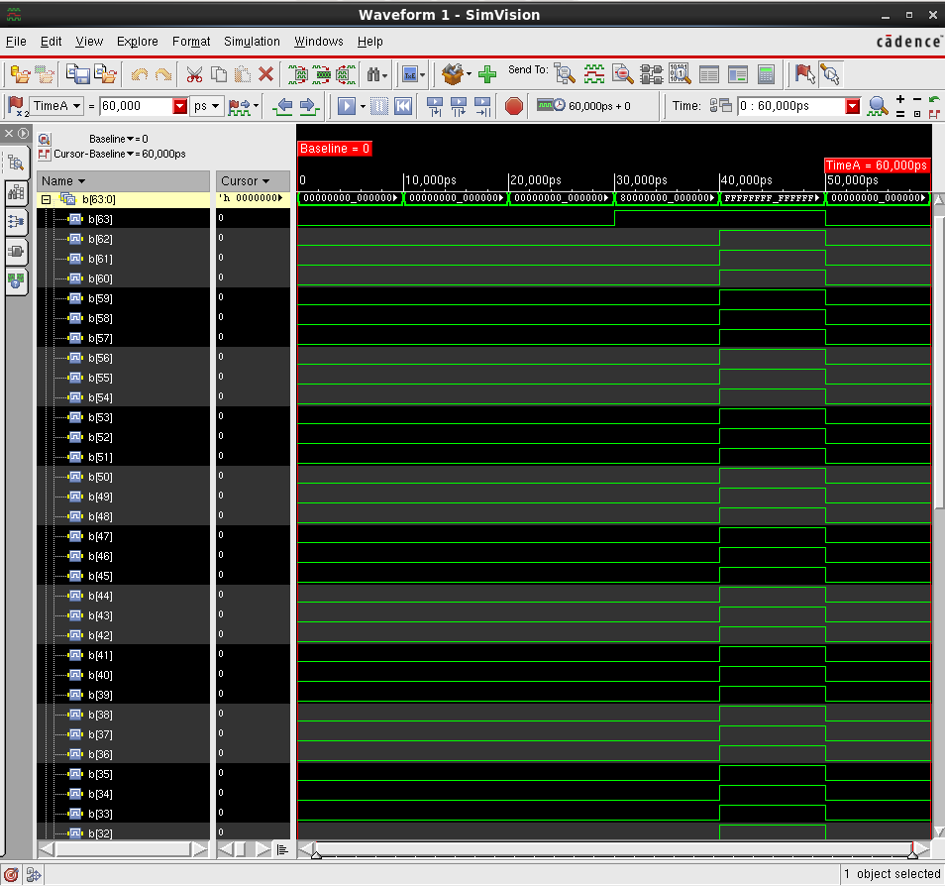

Figure-1.5.2. SimVision Output Waveform for 64-bit FullAdder Test-bench, showing the input(B31-0), selector lines, and output
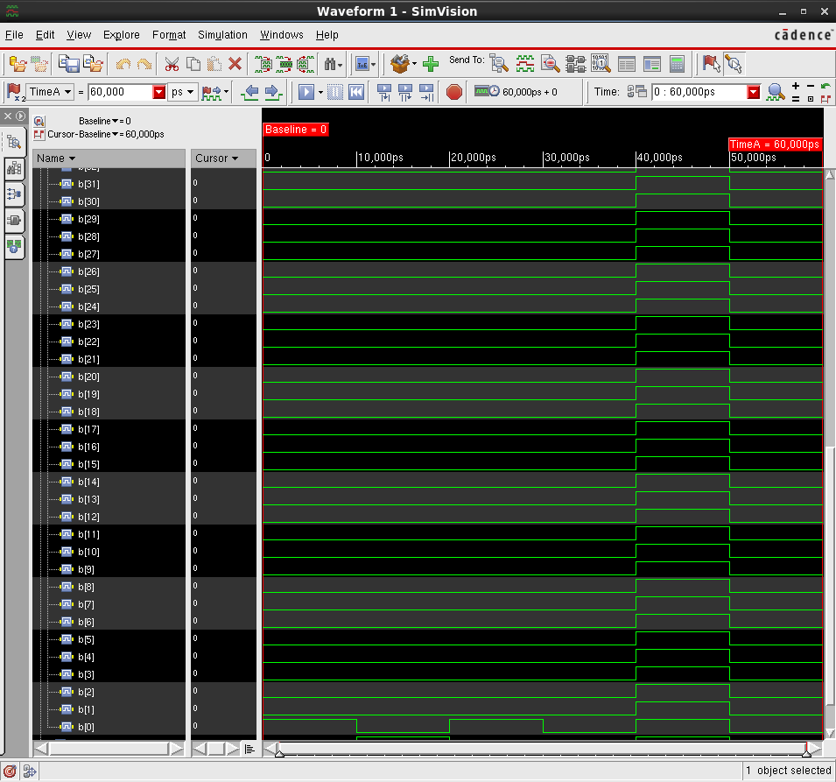

Figure-1.5.2. SimVision Output Waveform for 64-bit FullAdder Test-bench, showing the sums(63-32), selector lines, and output
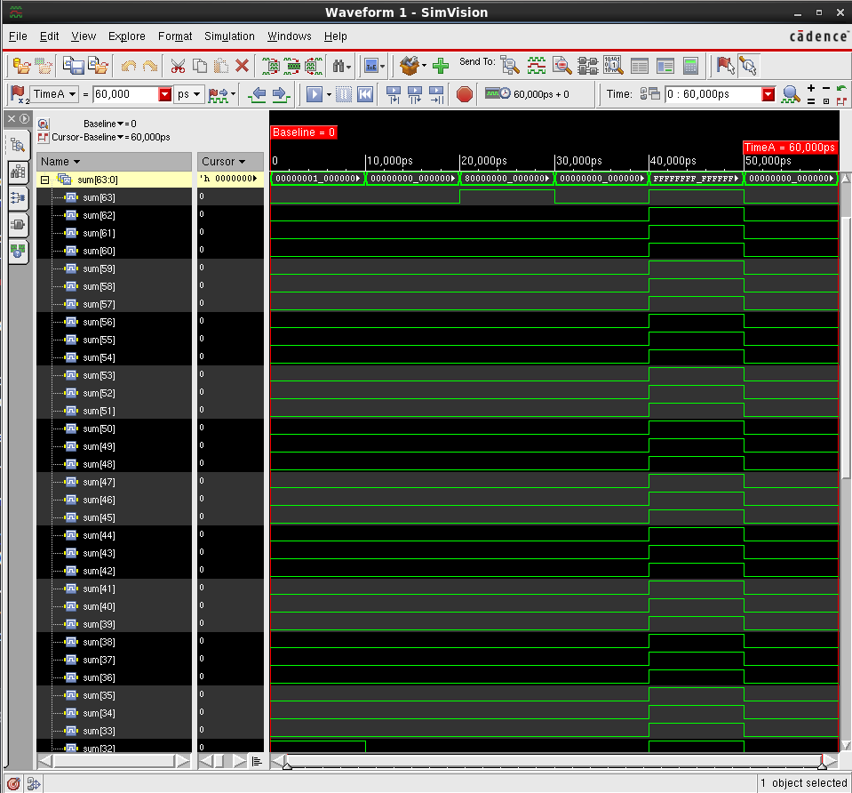

Figure-1.5.2. SimVision Output Waveform for 64-bit FullAdder Test-bench, showing the sums(31-0), selector lines, and output
